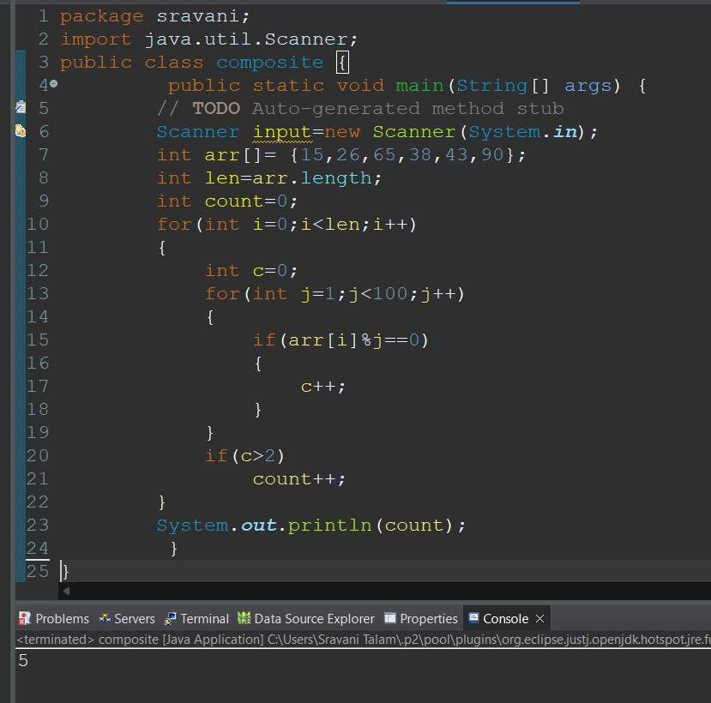

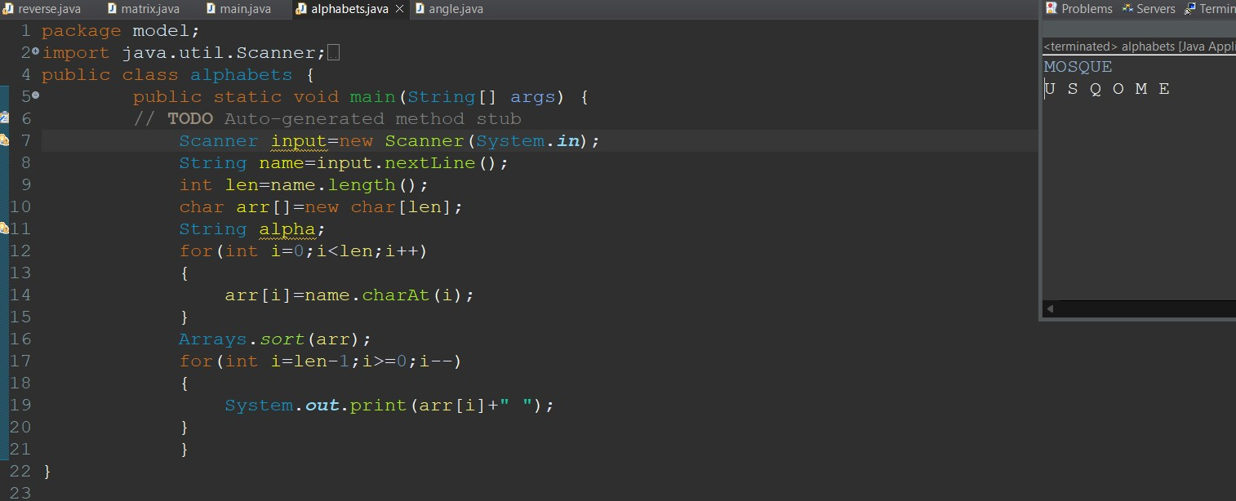

CONSONANTS & VOWELS

package model;

import java.util.Scanner;

public class main {

public static void main(String[] args) {

// **TODO** Auto-generated method stub

Scanner input=new Scanner(System.***in***);

String name=input.nextLine();

int len=name.length();

char a[]=new char[len];

char vow[]=new char[len];

char con[]=new char[len];

int v=0,c=0;

for(int i=0;i<len;i++)

{

a[i]=name.charAt(i);

if(a[i]=='a'||a[i]=='e'||a[i]=='i'||a[i]=='o'||a[i]=='u'

||a[i]=='A'||a[i]=='E'||a[i]=='I'||a[i]=='O'||a[i]=='U')

{

vow[v] = a[i];

v++;

}

else

{

con[c] = a[i];

c++;

}

}

System.***out***.print("Consonants: ");

for(int i=0;i<v;i++)

{

System.***out***.print(vow[i]);

}

System.***out***.print("\nvowels: ");

for(int j=0;j<c;j++)

{

System.***out***.print(con[j]);

}

}

}

OUTPUT

i am a programmer

vowels: iaaoae

consonants: m prgrmmr

MATRIX MULTIPLICATION

OUTPUT

Enter the number of rows of matrix1

2

Enter the number columns of matrix 1

2

Enter the number of rows of matrix2

2

Enter the number of columns of matrix 2

2

Enter the elements of matrix1

1 2

5 3

Enter the elements of matrix2

2 4

3 1

output matrix:-

8 6

19 23

SUM OF N DIGITS OF ARRAY

package model;

import java.util.Scanner;

public class reverse {

public static void main(String[] args) {

// **TODO** Auto-generated method stub

Scanner input=new Scanner(System.***in***);

int n=input.nextInt();

int sum=0;

while(n!=0)

{

int rem=n%10;

sum=sum+rem;

n=n/10;

}

System.***out***.println(sum);

}

}

OUTPUT

254

11